Project Title : Image Segmantaion (number 1,2 )

Team members :

1. محمود إيهاب عبد العزيز الأبصيري
2. عبد الله سمير حسين
3. عبد المنعم وجيه عبد المنعم
4. إبراهيم عماد الدين ابراهيم
5. نادين عماد الدين
6. فاطمه محمد
7. محمد نصر البنا
8. يوسف حسن ابوزيد

Project description:

GUI :

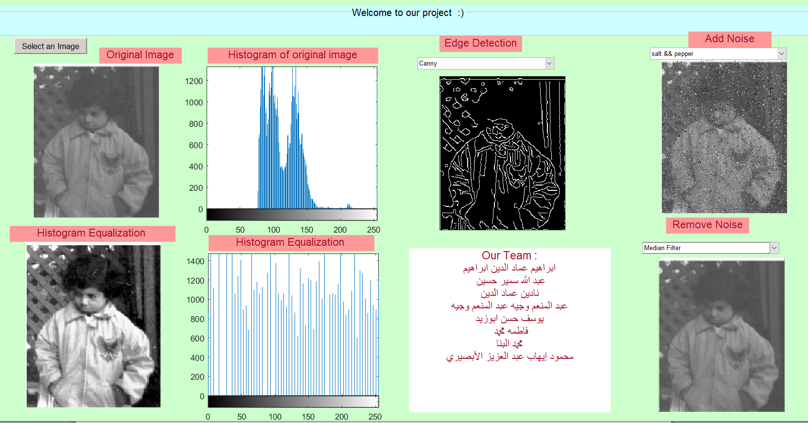

.Fig file format :

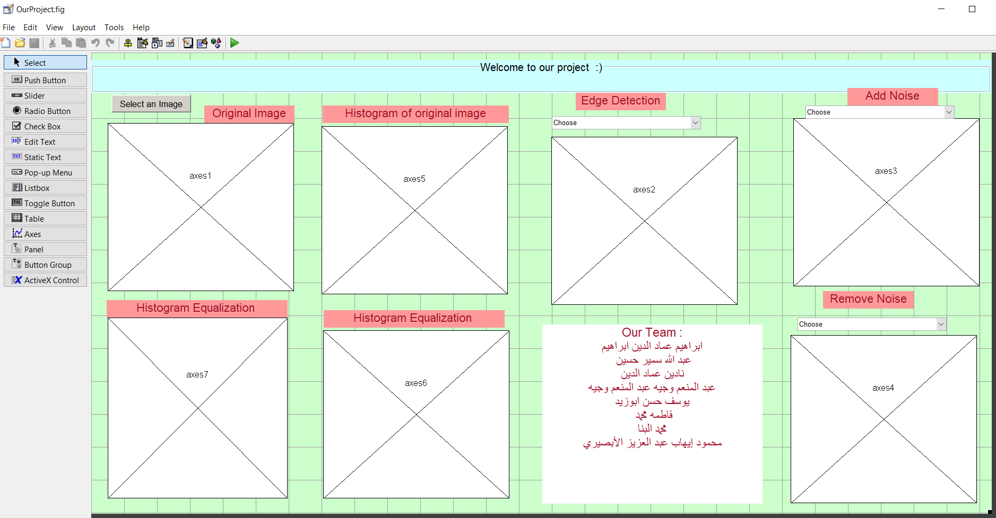

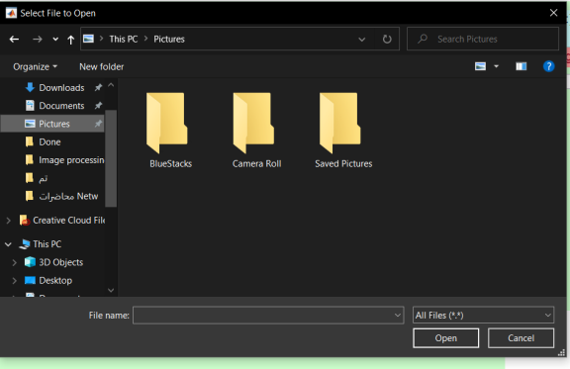Project Objects :

1. Image selection from disk:

We use ( uigetfile({'\*.\*'})) to get image file name and path

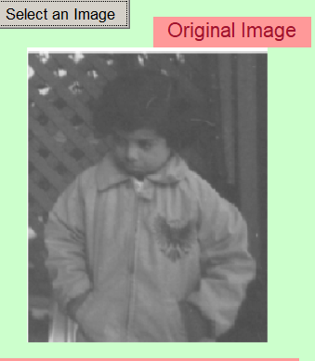Then we create the full path and store it using:

imageLocation = fullfile(path,file);

Now we can read this image by:

RGB = imread(imageLocation);

Then display this RGB image on axes1

Now we need an Gray scale image to perform Filters on it so we convert the image to gray scale using:

GrayImg = rgb2gray(RGB);

1. We Applied a histogram Equalization on it to enhance the image by using :

enhanced = histeq(GrayImg);

1. We displayed the image histogram and enhanced histogram by using :

imhist(GrayImg);

imhist(enhanced);

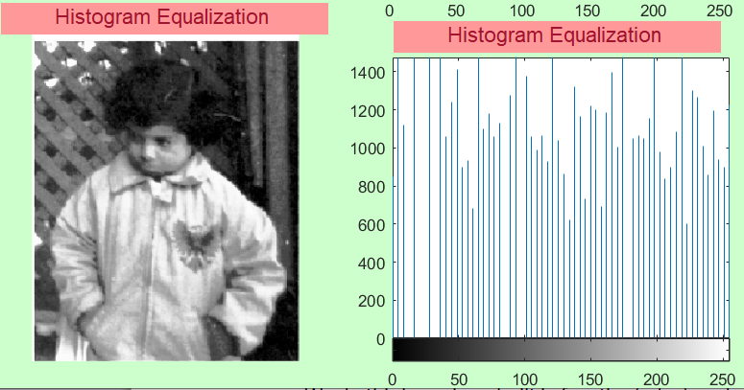

1. Now we perform Edge detection filters as (Robert , prewitt, canny ,LOG,DOG,Sobel)

We do this by using a built in function(edge) and pass to it the gray scale image and our choosen filter as :

edge(GrayImg ,'Roberts')

Edge = edge(GrayImg ,'Prewitt')

Edge = edge(GrayImg ,'Sobel')

Edge = edge(GrayImg ,'canny')

Edge = edge(GrayImg ,'Log')

But in case of DOG filter we use Difference of 2 Gaussian masks where (DOG) consist of ☺

Each Gaussian mask we created it using fspecial function as following

gaussian1 = fspecial('Gaussian', 21, 15);

gaussian2 = fspecial('Gaussian', 21, 20);

dog = gaussian1 - gaussian2;

then we applied this mask to the image but image must be in double format as follow:

Edge = conv2(double(GrayImg), dog);

1. Now we display this filtered image on our project GUI
2. Add Noise section :

We have different types of additive noise but we choose 2 types : salt & pepper and Gaussian noise

As we know salt & pepper noise displayed as "On and Off" pixels or white and black pixels

And Gaussian noise is Gaussian white noise with constant mean and variance

We use a built in function to perform these filters which is imnoise()

We pass to it the gray scale image and kind of noise we want to implement as follow:

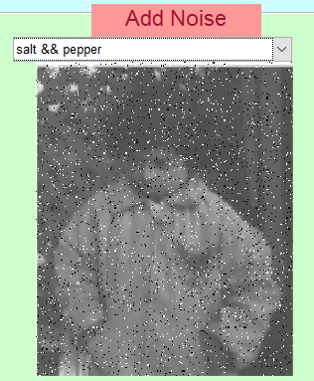Noise = imnoise(GrayImg ,'salt & pepper')

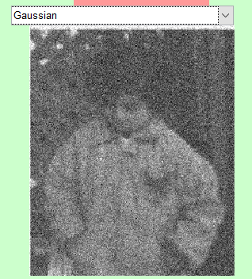

Noise = imnoise(GrayImg ,'gaussian')

1. Remove Noise Section :

we have different ways to remove noise from image we choose the average filter and median filter in our project for examples

we use a built in function to perform a median filter : medfilt2() as follow :

Filtered = medfilt2(Noise);

In case of average filter we use fspatial() function to create average mask with window size 3 then we applied the filter to our noisy image as following :

Filtered = filter2(fspecial('average',3),Noise)/255;